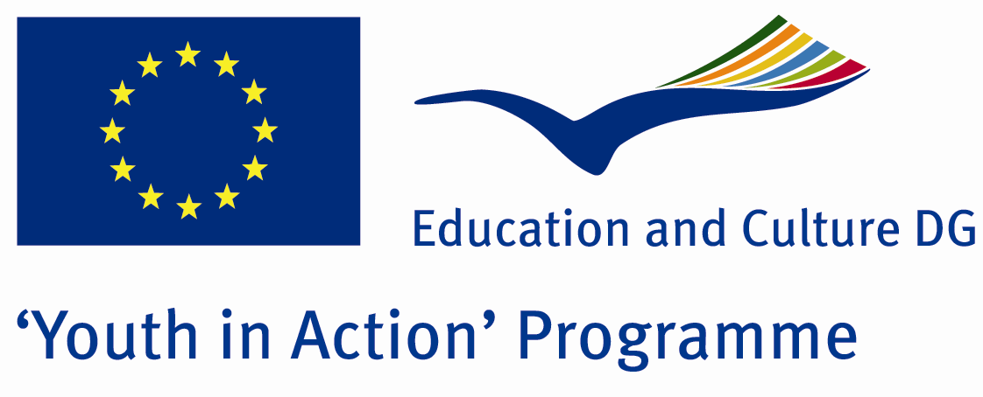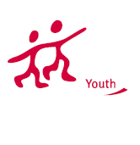

Action 4.3
Project Summary; Collage years are the most beautiful days in our lives. What then? According to the International Labour Organization, youth unemployment reached record levels and are increasing on a global scale. 81 of 620 million employable people are unemployed. Will we be a part of that statistics? We will develop projects for the prevention of youth unemployment, and attract the attention of European public to that matter.

Project Title; SCHOOL IS OVER. WHAT IS NEXT?

Date and Venue ; 22-28 August 2012
Place: Tekirdağ, Turkey.

Target Group ; Municipalities, City Councils and Non-Governmental organizations,
youth groups,culture and art groups,e.t.c

Participants ; 5 people from each country (over 18 -25 ). Totally 8 countries.

Conditions ; Accommodation, board and programme costs will be financed through European Commission Youth in Action Programme . Travel costs will be reimbursed in 70% (APEX Tarrifs). Organizations from all 27 EU member countries plus Liechtenstein , Norway and Iceland are eligible to take part.

Working language: English

Organisator group:Group Trakya

How to apply: If you are interested, please send your Part III forms to
by e-mail please (in word file). Scan Part3 format is enough for application.(Fulfilled Part III which you can find in the attachment, of course signed and stamped) ..

Contact e-mail: grouptrakya@gmail.com

